CECS 491A - Sec 6 - Project Plan Document

Project Name: ArrowNav

Team Longhorn:

Brayan Fuentes

Christian Lucatero

Curtis Nishihira

Miguel Zavala

Spencer Gravel (Team Leader)

October 27, 2021

|  |
| --- |
|  |
|
|
|
|
|
|
|
|
|
|
|
|

1. Overview
   1. Project Overview

ArrowNav is a campus companion web application that provides useful information and assistance to both new and current students at California State University Long Beach. The application will display locations, provide foot traffic updates, integrate student schedules into their accounts for the application, and increase student productivity while on campus through a variety of features. The goal of our web application will be to make it easier for students to navigate campus and increase their productivity on campus while still making it an interactive and enjoyable application to use on a semi-regular basis through convenience, incentives, and usability.

* 1. Project Plan Evolution

As this document defines the project’s scope and outlines the goals set in place for the project, it will be treated as a living document and will be updated periodically as the project progresses. These updates will come from changes that the client might have or from new information that has come to light.

* 1. Project Assumptions

This team is composed of full time students not employees who will be taking part in multiple courses throughout the project plan schedule. Therefore team capacity will be dependent on outside factors such as other classes. Additionally this causes the team budget to be limited to mostly free options.

1. Milestones
   1. Milestones

|  |  |  |  |
| --- | --- | --- | --- |
| **Milestones** | **Description** | **Deliverables** | **Planned Date** |
| Project Start | First date of Sprint 0 |  | 8/23/21 |
| Project Proposal | Initialize, edit, finalize and submit the project proposal | Proposal Document | 9/24/21 |
| Tech Spec,BRD,Site Map,High Level Design | Initialize, edit, finalize and submit the tech spec, BRD, site map, high level design. | Tech Spec,BRD, Site Map, HL Design | 10/06/21 |
| Project Plan,Test Plan,Network Diagram | Initialize, edit, finalize and submit the project plan,test plan, network diagram | Project Plan, Test Plan, Network Diagram | 10/27/21 |
| Logging, User Management, LL Design | Initialize, edit, finalize and submit the Logging, UM, LL Design | Logging, UM, LL Design | 12/08/21 |
| Environment Setup | Finish setting up the network and software environment. | IDEs, Web Servers, Cloud Provider, Database, Database Server | 2/2/22 |
| User Interface | Research, develop and test the UI. | User Interface | 2/16/22 |
| Account Management | Research, develop and debug code for account management service. | Account Management feature | 2/16/22 |
| Location  Search | Research, develop and debug code for and search service. | Routing and Capacity Features | 3/25/22 |
| Survey | Research, develop and debug code for survey service. | Survey Feature | 3/16/22 |
| Rewards  Notifications | Research, develop and debug code for rewards and notification service. | Rewards and Notification Features | 4/27/22 |
| Testing | Conduct final testing of the project as a whole. | Automated Tests | 5/1/22 |
| Final Deadline | Final day of the project | Final Product | 5/1/22 |

1. Road Map

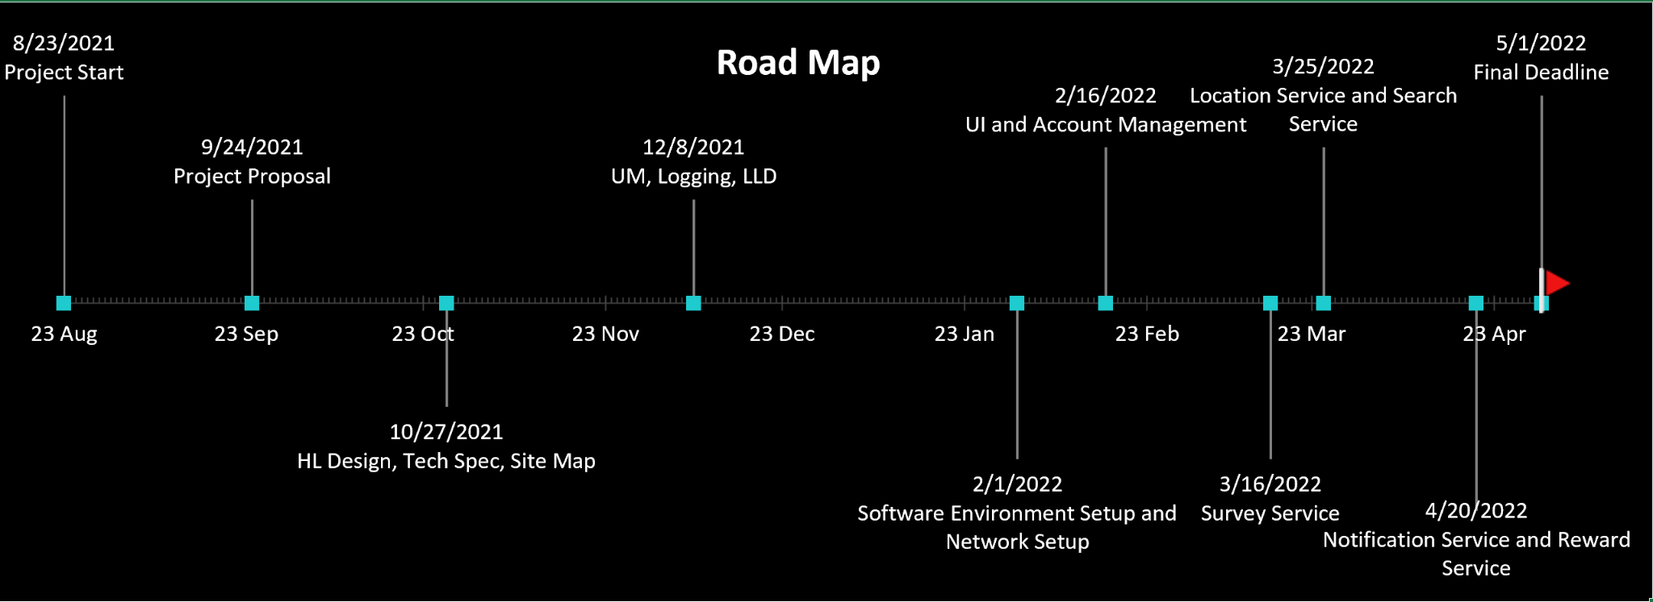

1. Timeline

The following timelines display the sprints as well as the implementations that will be worked on during these sprints. The implementation of smaller sprints will help our team understand the project’s progression and be able to adjust accordingly to any setbacks that we might have moving forward.

**Product Timeline**

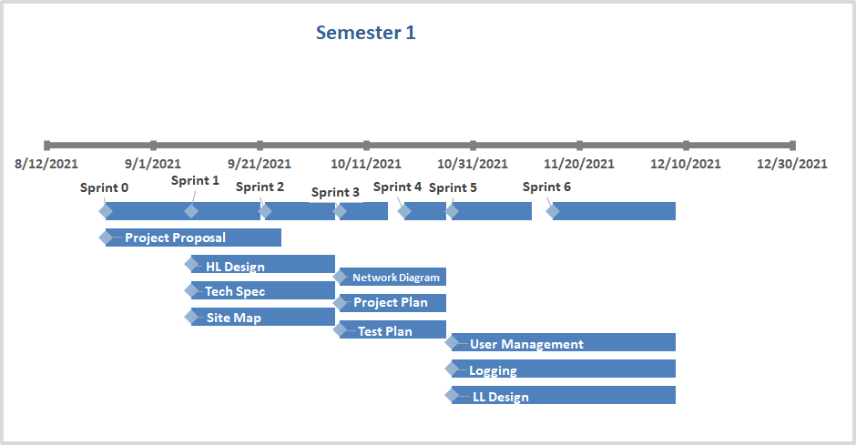

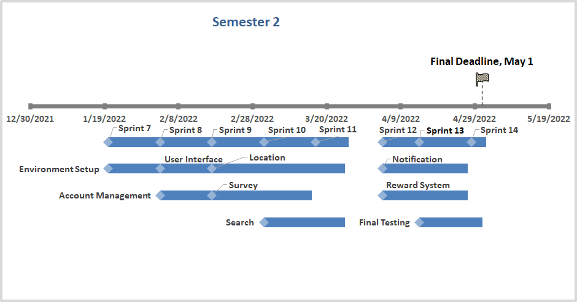

1. Sprint Breakdown

|  |  |  |
| --- | --- | --- |
| Sprint 0  8/30/2021 - 9/6/2021 | | Hours  Total: 59 |
| Project Proposal   * Spencer | Writing | 59 hours |

|  |  |  |
| --- | --- | --- |
| Sprint 1  9/7/2021 - 9/20/2021 | | Hours  Total: 109 |
| Project Proposal   * Spencer | Writing | 40 hours |
| High Level Design   * Curtis | Writing | 18 hours |
| BRD   * Miguel | Writing | 20 hours |
| Site Map   * Brayan | Writing | 16 hours |
| Tech Spec   * Christian | Writing | 15 hours |

|  |  |  |
| --- | --- | --- |
| Sprint 2  9/21/2021 - 10/4/2021 | | Hours  Total: 115 |
| Project Proposal   * Spencer | Writing | 5 hours |
| High Level Design   * Curtis | Writing | 28 hours |
| BRD   * Miguel | Writing | 30 hours |
| Site Map   * Brayan | Writing | 27 hours |
| Tech Spec   * Christian | Writing | 25 hours |

|  |  |  |
| --- | --- | --- |
| Sprint 3  10/5/2021 - 10/14/2021 | | Hours  Total: 60 |
| Project Plan   * Brayan | Writing | 24 hours |
| Test Plan   * Miguel | Writing | 24 hours |
| Network Diagram   * Spencer | Writing | 12 hours |

|  |  |  |
| --- | --- | --- |
| Sprint 4  10/15/2021 - 10/25/2021 | | Hours  Total: 60 |
| Project Plan   * Brayan | Writing | 24 hours |
| Test Plan   * Miguel | Writing | 24 hours |
| Network Diagram   * Spencer | Writing | 12 hours |

|  |  |  |
| --- | --- | --- |
| Sprint 5  10/26/2021 - 11/11/2021 | | Hours  Total: 75 |
| Low Level Design   * Curtis | Writing | 25 hours |
| Logging   * Christian | Writing | 25 hours |
| User Management   * Spencer | Writing | 25 hours |

|  |  |  |
| --- | --- | --- |
| Sprint 6  11/12/2021 - 12/7/2021 | | Hours  Total: 75 |
| Low Level Design   * Curtis | Writing | 25 hours |
| Logging   * Christian | Writing | 25 hours |
| User Management   * Spencer | Writing | 25 hours |

|  |  |  |
| --- | --- | --- |
| Sprint 7  1/20/2022 - 2/2/2022 | | Hours  Total: 225 |
| Software Environment Setup   * Spencer | IDE Configuration | 25 hours |
| Github Repository Configuration | 20 hours |
| Network Setup   * Brayan | Cloud Configuration | 60 hours |
| Web Server Configuration | 50 hours |
| Database Configuration | 20 Hours |
| Database server configuration | 50 hours |

|  |  |  |
| --- | --- | --- |
| Sprint 8  2/3/2022 - 2/16/2022 | | Hours  Total: 240 |
| User Interface   * Miguel | Research | 20 hours |
| Development | 60 hours |
| Error Handling | 20 hours |
| Testing | 10 hours |
| Logging | 5 hours |
| Account Management   * Curtis | Research | 20 hours |
| Development | 40 hours |
| Error handling | 20 hours |
| Testing | 10 hours |
| Logging | 5 hours |
| Input Validation | 10 hours |
| Security | 20 hours |

|  |  |  |
| --- | --- | --- |
| Sprint 9  2/17/2022 - 3/2/2022 | | Hours  Total: 190 |
| Location Service   * Spencer | Research | 30 hours |
| Development | 70 hours |
| Survey Service   * Christian | Research | 20 hours |
| Development | 40 hours |
| Error handling | 20 hours |
| Testing | 10 hours |

|  |  |  |
| --- | --- | --- |
| Sprint 10  3/3/2022 - 3/16/2022 | | Hours  Total: 200 |
| Location Service   * Spencer | Development | 50 hours |
| Error Handling | 20 hours |
| Survey Service   * Christian | Logging | 20 hours |
| Input Validation | 10 hours |
| Security | 20 hours |
| Search Service   * Brayan | Research | 20 hours |
| Development | 50 hours |
| Input validation | 10 hours |

|  |  |  |
| --- | --- | --- |
| Sprint 11  3/17/2022 - 3/25/2022 | | Hours  Total: 170 |
| Location Service   * Spencer | Testing | 60 hours |
| Logging | 40 hours |
| Search Service   * Brayan | Error handling | 10 hours |
| Testing | 40 hours |
| Logging | 20 hours |

|  |  |  |
| --- | --- | --- |
| Sprint 12  4/4/2022 - 4/13/2022 | | Hours  Total: 180 |
| Testing   * Christian | Final System Tests | 20 hours |
| Final Users Tests | 20 hours |
| Final Code Checks | 20 hours |
| Rewards Service   * Curtis | Research | 20 hours |
| Development | 30 hours |
| Error handling | 10 hours |
| Notifications Service   * Miguel | Research | 20 hours |
| Development | 30 hours |
| Error handling | 10 hours |

|  |  |  |
| --- | --- | --- |
| Sprint 13  4/14/2022 - 4/27/2022 | | Hours  Total: 150 |
| Testing   * Christian | Final System Tests | 30 hours |
| Final Users Tests | 30 hours |
| Final Code Checks | 30 hours |
| Rewards Service   * Curtis | Logging | 10 hours |
| Testing | 20 hours |
| Notifications Service   * Miguel | Logging | 10 hours |
| Testing | 20 hours |

|  |  |  |
| --- | --- | --- |
| Sprint 13  4/27/2022 - 5/4/2022 | | Hours  Total: 120 |
| Testing   * Christian | Final System Tests | 30 hours |
| Final Users Tests | 30 hours |
| Final Code Checks | 30 hour |

1. Cost Estimation

|  |  |  |  |  |
| --- | --- | --- | --- | --- |
| Personnel Cost | | | | |
| **Team Members** | **Title** | **Hourly** | **Days** | **Cost** |
| Spencer Gravel | Project Manager\ Software Developer | 45$ | 180 | $24,300 |
| Brayan Fuentes | Software Developer | 42$ | 180 | $22,680 |
| Christian Lucatero | Software Developer | 42$ | 180 | $22,680 |
| Curtis Nishihira | Software Developer | 42$ | 180 | $22,680 |
| Miguel Zavala | Software Developer | 42$ | 180 | $22,680 |
| **Hourly rates based on average salary for position and cost calculated assuming students are not full time** | | | Total Cost: | $115,020 |

|  |  |  |  |
| --- | --- | --- | --- |
| Technology Cost | | | |
| **Amount** | **Technology Type** | **Technology Name** | **Cost** |
| 5 | Communication | Discord v10.0.19043 | 0$ |
| 5 | Documentation | Google Docs v1.21.382.02.30 | 0$ |
| 5 | Google Sheets  v1.21.402.01.35 | 0$ |
| 5 | Drawio  v15.3.8 | 0$ |
| 5 | Version Control | Github Desktop v2.9.3 | 0$ |
| 5 |  | Visual Studio 2019 - Community Edition v16.11 | 0$ |
| 5 | Project Management | Zenhub v2.0 | 0$ |
| 5 | SQL Server Management | SQL Server Express 2019 v15.0.2000.5 | 0$ |
| 5 | Web Server | IIS 10 | 0$ |
| 5 | Cloud Provider | Microsoft Azure (database and web servers) | 0$ |
| 5 | Software Library | .NET Framework | 0$ |
| 5 | Automated Testing | Selenium v4.0 | 0$ |
| 5 | BrowserStack Automate | 0$ |
| 5 | Front End JavaScript Framework | React v17.0.2 | 0$ |
| 5 | Server Side Programming framework | .NET Framework | 0$ |
| Total Cost: | | | 0$ |

1. Risk Estimation
   1. Scope Creep
      1. Description
         1. Changes to the project scope as a result of client change requests, technology limitations, or team limitation
      2. Impact
         1. Has high impact depending on how large the scope creep is could entail more work for the team also affecting the delivery timeline
      3. Probability
         1. Moderate probability as there is expected to be some kind of scope creep in most projects but a large scope creep that cannot be avoided has very low probability at this stage in the project
      4. Migration strategy
         1. address changes viability and team capacity
   2. Team Availability
      1. Description
         1. The limited availability that the team members might have with external commitments or during breaks.
      2. Impact
         1. Has the potential to have a moderate impact on the project’s performance and affect the schedule in place.
      3. Probability
         1. The probability of this occurring is between 25% and 75%
      4. Mitigation Strategy
         1. Accept the Risk
            1. The team will have meetings to minimize the impact of having a team member absent for the period of time and to collaborate with each other to keep the project’s schedule on track.
   3. Insufficient Time
      1. Description
         1. Run out of time to complete the aspects listed for a given sprint.
      2. Impact
         1. Has the potential to have a high impact on the project’s performance and heavily affect the schedule in place.
      3. Probability
         1. The probability of this occurring is between 50% and 85%.
      4. Mitigation Strategy
         1. Accept the risk
            1. We will continuously update the project schedule to be able to spread the workload efficiently and reduce some of the non essential tasks.
   4. Pandemic
      1. Description
         1. Outbreaks or spikes in Covid19 pandemic could cause team availability or workflow to be interrupted
      2. Impact
         1. Potential is medium impact virtual work will remain unchanged but any in person team events will be canceled and team motivation or health could be deterred by community restrictions.
      3. Probability
         1. The probability of this occurring is 50% with rising vaccinations there is a possibility of more variants occurring and loosened restrictions on gatherings could spread the virus.
      4. Mitigation Strategy
         1. Nothing the team can do to mitigate changes in the pandemic except following CDC guidelines and limiting exposure to large amounts of people.